
QUALITY ALERT

Customer: Reliance Date: February 8, 2018
Die: 1036B Colour: ALL
Type of Complaint: Reliance Complaint

Q.A # Q.I.R # CUSTOMER NCR #

Description: Reliance complaint – Leg too long when cut interfering with installation of the window

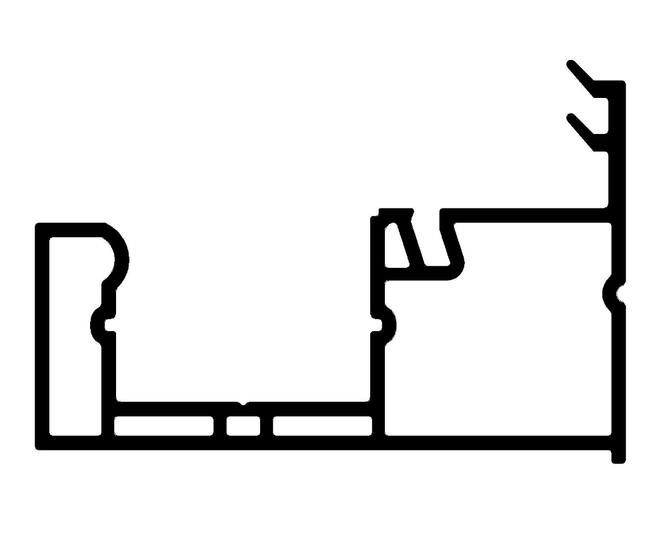
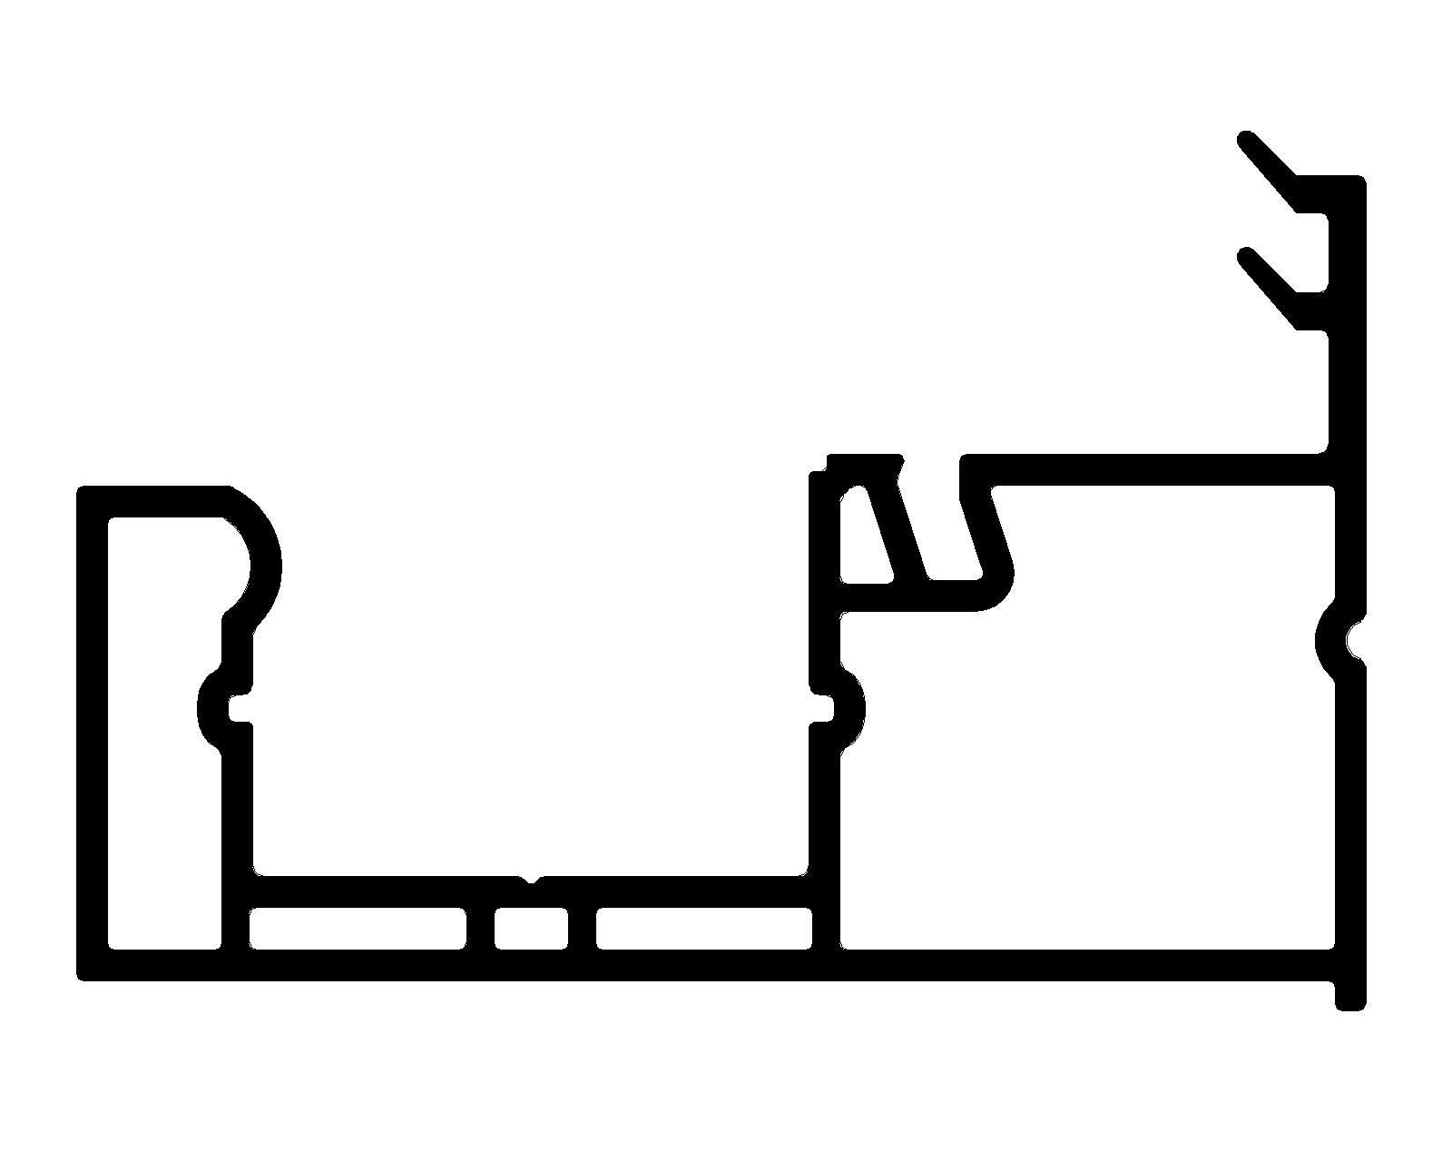

0.060”

0.040 – 0.100 MAX

BY SIGNING BELOW, YOU ACKNOWLEDGE THE PROBLEM ABOVE AND AGREE TO MONITOR THIS ISSUE IN FUTURE PRODUCTION RUNS.
DAY SHIFT |  | AFTERNOON SHIFT |  | NIGHT SHIFT
NAME | SIGNATURE | NAME | SIGNATURE | NAME | SIGNATURE

